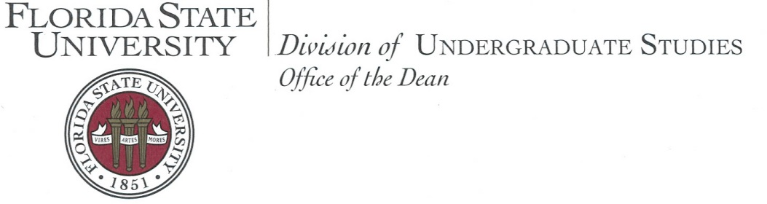

Welcome to the second annual College Life Coaching Institute at Florida State University! Our talented and dedicated College Life Coaches have designed this program to share their innovative model in an interactive environment. Our goal is to provide you with the most personal and helpful experience possible. Whether you are seeking to build a program or focusing on hands-on skills development, I am confident that you will come away with new ideas about how to foster student success on your campus.

It is exciting and fulfilling to support students through the new experience of university life. Each student brings a unique story and set of experiences and reacts to the college transition in a distinctive way. What it means to find community and flourish in an academic setting also varies from student to student and involves developing a range of new skills.

Since 2008, the Florida State University Advising First Center for College Life Coaching has worked to help students make the smoothest possible transition to the university setting, engage fully in their own personal and professional development, and overcome obstacles that may lead to dismissal or withdrawal from the university.

To accomplish this, coaches must develop the expertise to establish a connection that empowers students to take their academic lives into their own hands. The results of college life coaching here at Florida State University have been quite inspiring. For the year 2016-17, we saw an overall first-year retention rate of 92% in the populations selected to receive coaching services as well as a significant improvement in students’ satisfaction with their educational experience.

We are excited to share with you what we have learned, learn from your experiences, and strategize together about how best to help students make the most of their college experience. Keeping students engaged, helping them make timely progress toward degree completion, and deepening their understanding of themselves and their world are common goals for all of us involved in higher education. I trust that your participation in the Institute will help bring you closer to achieving these goals and will enhance your commitment to this important work.

Dean of Undergraduate Studies
Florida State University
2018 College Life Coaching Institute
Schedule at a Glance
Garnet Track

Wednesday, June 6, 2018
8:00 am-8:30 am | Shuttle Services
8:30 am-9:30 am | Check-in & Breakfast
9:30 am-10:15 am | Welcome & Keynote Address
10:30 am-12:15 pm | Session
12:30 pm-1:30 pm | Lunch
1:45 pm-2:15 pm | Building Tour or Team Builder
2:30 pm-4:30 pm | Session
4:30 pm-5:00 pm | Shuttle Services
5:30 pm | Networking at Madison Social (suggested)

Thursday, June 7, 2018
8:30 am-9:00 am | Shuttle Services
9:00 am-11:00 am | Session
11:15 am-12:15 pm | Concurrent Workshops
12:30 pm-1:30 pm | Lunch
1:45 pm-3:30 pm | Session
3:45 pm-4:45 pm | Concurrent Workshops
4:45 pm-5:15 pm | Shuttle Services

Friday, June 8, 2018
8:30 am-9:00 am | Shuttle Services
9:00 am-10:00 am | Session
10:15 am-11:30 am | Session
11:30 am-12:00 pm | Closing Session
12:00 pm-12:30 pm | Shuttle Services

Social Media and WiFi Information
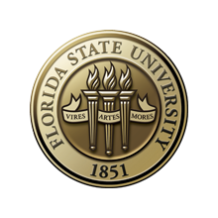
Follow us!
Twitter: @FSULifeCoaching
Facebook: FSU Advising First Center for College Life Coaching
On your mark. Get set.
CONNECT! To FSU’s WiFi
Quick Steps to CONNECT!:
- Turn on your WiFi and select “FSUGuest.”
- Open your browser and click “Guest Registration.”
- Enter your cell phone number and carrier.
- Click “Register.”
- Check your cell phone for a text with a username and password.
- Enter the username and password.
- Click “Log In.”
#FSUCLCInstitute
Keynote Speaker

Dr. Billy Close
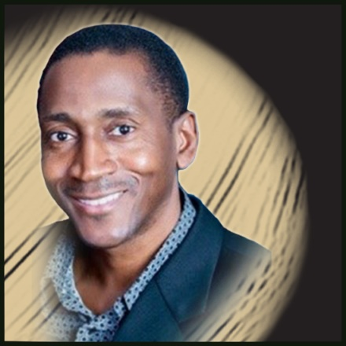

Dr. Billy Close is currently an Assistant Professor and Director of Service Learning and Mentoring in the College of Criminology & Criminal Justice at the Florida State University (FSU). Dr. Close is also President, Paradigm Consultants & Associates, Inc. and Founder & Executive Director of Beyond the Athlete, Inc., a 501(c) (3) non-profit organization committed to harnessing the powers of faith, family, sport, service learning, and mentoring for educational, character, and life skill development among youth & young adults. Dr. Close graduated from Lincoln High School in Tallahassee, Florida where earned High School All-American honors and was a two-time State Champion in Track and Field. Dr. Close earned a dual B.S. in Psychology and Criminology, and both his M.S. and Ph.D. degrees in Criminology and Criminal justice from FSU.
Dr. Close has served as a Member of Florida’s Council on the Social Status of Black Men and Boys, and as Board Member for several organizations including: The Leon County School Foundation, The Florida State University Athletics, The Florida State University International Programs Association, Inc., The Florida Department of Education College Reach-Out Program Advisory Council, The Tallahassee Associated Marine Institute, The Lincoln High School Alumni Association, and The FSU Varsity Club. His current research interests include Racial and Ethnic Differences in Traffic Stops and Driver Treatment, as well as the general areas of Theory & Dynamics of Minority Criminality, Racial Profiling, Sports & Crime, Mentoring Strategies for African-American Youth, Ethnicity and Methodology, Black Crimmythology, Conflict Reduction, and Multiculturalism. Dr. Close is married to Fran T. Close, Ph.D. who is currently a Professor in the Institute of Public Health and the College of Pharmacy and Pharmaceutical Sciences at Florida A& M University. They have three daughters, Nia Sekayi, Nataki Adia and Nyla Imani.

Detailed Schedule
WEDNESDAY, JUNE 6, 2018
8:00 am-8:30 am | Shuttle Services | Four Points/ Visitor Parking to the Student Services Building (SSB)
8:30 am-9:30 am | Check-in & Breakfast | Location: SSB Foyer & 203
9:30 am-10:15 am | Welcome & Keynote Address | Shae Roberts, Program Manager  Dr. Billy Close, Keynote Speaker  Location: SSB 203
10:30 am-12:15 pm | Program Overview & Coaching Skills  (Creating a Safe Space & Connection) | Erica Cucinella, FTIC Senior Coach  Hannah Byrd, CARE Senior Coach  Justin Hall, FTIC Coach  Location: SSB 203
12:30 pm-1:30 pm | Lunch | Seminole Café
1:45 pm-2:15 pm | Building Tour or Team Builder Activity | Building Tour  Erica Cucinella, FTIC Senior Coach  Location: William Johnston Building  Team Builder  Rolando Torres, FTIC Senior Coach  Felicia Dilbert, FTIC Coach  Location: SSB 203
2:30 pm-4:30 pm | Coaching Skills  (Active Listening & Empowering Questions) | Rachel McPherson, FTIC Senior Coach  Jacourie Clark, CARE Coach  Location: SSB 203
4:30 pm-5:00 pm | Shuttle Services | SSB to Four Points/ Visitor Parking
5:30 pm-until | Networking (suggested) | Location: Madison Social  705 S. Woodward Ave #101  Tallahassee, FL 32304

THURSDAY, JUNE 7, 2018
8:30 am-9:00 am | Shuttle Services | Four Points/ Visitor Parking to the Student Services Building (SSB)
9:00 am-11:00 am | Coaching Skills  (Holding Student’s Agenda, Prioritizing & Clarifying Direction) | Rolando Torres, FTIC Senior Coach  Anthony Garrett, FTIC Coach  Location: SSB 203
11:15 am-12:15 pm | Concurrent Sessions:  “Connections through peer coaching: A model for supporting student success”  -OR-  “Connecting the Team Before Impacting the Students’ Dreams: Using Personality Assessments to Create Team Cohesion” | Peer Coaching  Dr. Reginald Simmons  Alexandra Castillo  Central Connecticut State University  Location: SSB 203  Team Cohesion  Shae Roberts  Florida State University  Location: SSB 208
12:30 pm-1:30 pm | Lunch | Seminole Cafe
1:45 pm-3:30 pm | Coaching Skills  (Solution Focus, Affirm & Coach Confidence) | Jorge Bustamante, FTIC Coach  Emily Manning, FTIC Senior Coach  Bo Marcevski, CARE Coach  Location: SSB 203
3:45 pm-4:45 pm | Concurrent Sessions:  “Coaching as Advising for High Achieving Students”  -OR-  “Implementing a College Life Coaching Program within the Academic Advising Center: Small School Perspective” | High Achieving Students  Megan Gillman  Florida State University  Location: SSB 203  Small School Perspective  Susan Gleason  Jodi Burns  University of Pittsburgh-Bradford  Location: SSB 208
4:45 pm-5:15 pm | Shuttle Services | SSB to Four Points/ Visitor Parking

FRIDAY, JUNE 8, 2018
8:30 am-9:00 am | Shuttle Services | Four Points/ Visitor Parking to the Student Services Building (SSB)
9:00 am-10:00 am | Coaching Model | Rolando Torres, FTIC Senior Coach  Erica Cucinella, FTIC Senior Coach  Location: SSB 203
10:15 am-11:30 am | Guided Group Forum | Hannah Byrd, CARE Senior Coach  Emily Manning, FTIC Senior Coach  Jacourie Clark, CARE Coach  Location: SSB 203
11:30 am-12:00 pm | Closing Session:  Passing the Baton | Shae Roberts, Program Manager  Location: SSB 203
12:00 pm-12:30 pm | Shuttle Services | SSB to Four Points/ Visitor Parking

Workshop Abstracts

Thursday, June 7, 2018 11:15 am-12:15 pm

Connections through peer coaching: A model for supporting student success – SSB 203
Dr. Reginald Simmons and Alexandra Castillo, Central Connecticut State University

There is increasing recognition that pairing successful undergraduates similar in background and experience with other undergraduates in a mentoring relationship can be effective, particularly for enhancing the academic success of under-represented and first-generation students (Coleman Tucker, 2014; Johnson, 2013; & Strayhorn, 2012). One of the problems that some first-generation students experience is a lack of connection to their college campus, which is one of the non-academic factors that is key to college success (Lotkowski, Robbins, & Noeth, 2004). This presentation will introduce the audience to Success Central, a university-supported intervention where junior and senior students are trained to use college coaching techniques in a mentoring relationship designed to support the success of freshmen and sophomore first-generation students. The audience will hear from the mentoring team how they were chosen, trained, and supervised, as well as case-studies that demonstrate the intervention and the benefits to both the mentee and the mentor.

Connecting the Team Before Impacting the Students’ Dreams: Using Personality Assessments to Create Team Cohesion – SSB 208
Shae Roberts, Florida State University

Every team has the loud extravert, the quiet introvert, the sharp overachiever and the disengaged worker. Juggling all of these dynamics can be challenging and frustrating, and to add even more difficulty, every time someone leaves and/or is added, you have a brand new team! The key to strengthening cohesion is to build trust and transparency between the team and leadership, and between colleagues. Assessments such as True Colors ©, Myers Briggs ©, and Strengths Quest © are all tools available to identify the personality types, and strengths and weaknesses of the members on your team. However, assessment is only part of the equation. This interactive discussion will focus on the True Colors © assessment, setting structure, hiring based on your program’s vision and needs, addressing conflict based on personality types, and the importance of team building activities.

Thursday, June 7, 2018 3:45 pm-4:45 pm
Coaching as Advising for High Achieving Students – SSB 203
Megan Gillman, Florida State University

Coaching has proven a highly effective technique for increasing retention and success of at-risk college students, but how might it help students at the other end of the achievement spectrum? Often advisors and professors assume that gifted and high-achieving students have everything figured out, but the use of coaching strategies can encourage tremendous growth in these students as well. This presentation offers insight into how coaching can be integrated into every day advising sessions with high-achieving college students in order to help them develop a strong sense of autonomy and encourage them to achieve goals they may not have imagined.

Implementing a College Life Coaching Program within the Academic Advising Center: Small School Perspective – SSB 208
Susan Gleason and Jodi Burns, University of Pittsburgh-Bradford

The College Life Coaching (CLC) program was implemented as a pilot program at the University of Pittsburgh at Bradford (UPB) for the duration of the 2017-18 academic year. The University of Pittsburgh at Bradford serves approximately 1,500 students. Students determined to be at-risk (provisionally admitted) were invited to participate in the inaugural CLC program. This population was chosen in an attempt to raise retention rates and lower the rate in which these students were placed on academic probation. This presentation will provide an overview of how a CLC program was implemented at a small institution with limited resources and an overlapping of staff responsibilities. We will also look through a critical lens at the outcomes of this crucial first year and will conclude by sharing our vision for the future.

Thank you to our Sponsors!

Off Campus:
Barefoot Campus Outfitter
Smoothie King

On Campus:
Askew Student Life Center
FSU Bookstore
Career Center
Center for Global Engagement
Center for Health Advocacy and Wellness
Center for Leadership and Social Change
Dean of Students
Honors Program
FSU International Programs
Medical Response Unit
Museum of Fine Arts
Office of Business Services
Student Veterans Center
University Health Services Administration (5th Floor)
University Center Club
FSU Visitor Center

Askew Student Life Center is offering free admission to see Tomb Raider at 9:30 pm on Wednesday, June 7th, and Thursday, June 8th. See Institute bag for $1 popcorn ticket.
Address: 942 Learning Way, Tallahassee, FL 32304

