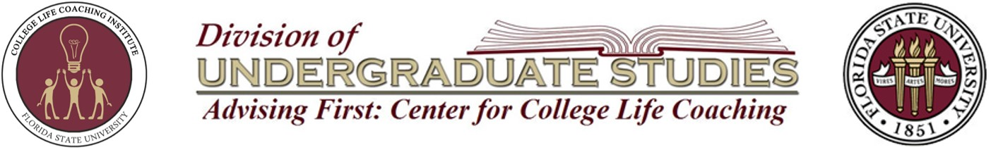

2019 FSU College Life Coaching Institute Overview
A Decade to Celebrate!
WEDNESDAY, JUNE 5TH
7:30am-8:30am | Check-in & Breakfast
8:30am-9:30am | Welcome & Keynote Address
 | Garnet Track  (Advisor) | Gold Track  (Administrator)
9:45am-11:00am | Coaching Program Overview &  Coaching Skill: Creating a Safe Space | Group Introductions and Research
11:15am-12:15pm | Coaching Skill: Connection | Program Specifics  (History, Structure, Staffing & Training)
12:15pm-1:15pm | Lunch (Catered)
1:30pm-2:30pm | Coaching Skill: Active Listening | Developing Program Outcomes
2:45pm-3:45pm | Coaching Skill: Empowering Questions | Proposal Drafting Time
4:00pm-5:00pm | Coaching Skill: Solution Focused | Special Topics  (Topics/questions provided by participants)
THURSDAY, JUNE 6TH
8:30am-9:30am | Coaching Skill: Holding Student’s Agenda | Coaching Skills Overview & Live Role Play
9:45am-10:45am | Coaching Skills: Prioritize & Clarify Direction | Dynamic Circular Model
11:00am-12:00pm | Coaching Skill: Affirming | Program Evaluation
12:00pm-1:00pm | Lunch (catered)
1:15pm-2:15pm | Coaching Skill: Coach Confidence | Coaching Leadership  (session led by the Keynote Speaker)
2:30pm-3:30pm | Workshops
3:45pm-4:45pm | Team Meetings
FRIDAY, JUNE 7TH
8:30am-9:30am | Role Play & Roundtable | Panel Discussion  (separated by status – new or existing program)
9:45am-10:45am | Dynamic Circular Model | Program Goal Planning/ Next Steps
10:45am-11:15am | Closing Session
11:15am-12:00pm | Celebration (with cake)

