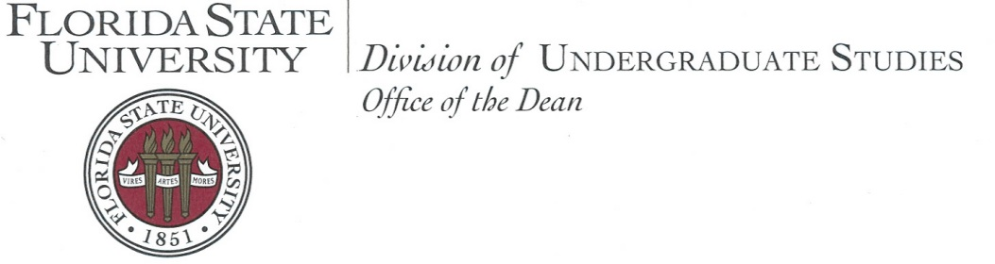

Welcome to the second annual College Life Coaching Institute at Florida State University! Our talented and dedicated College Life Coaches have designed this program to share their innovative model in an interactive environment. Our goal is to provide you with the most personal and helpful experience possible. Whether you are seeking to build a program or focusing on hands-on skills development, I am confident that you will come away with new ideas about how to foster student success on your campus.

It is exciting and fulfilling to support students through the new experience of university life. Each student brings a unique story and set of experiences and reacts to the college transition in a distinctive way. What it means to find community and flourish in an academic setting also varies from student to student and involves developing a range of new skills.

Since 2008, the Florida State University Advising First Center for College Life Coaching has worked to help students make the smoothest possible transition to the university setting, engage fully in their own personal and professional development, and overcome obstacles that may lead to dismissal or withdrawal from the university.

To accomplish this, coaches must develop the expertise to establish a connection that empowers students to take their academic lives into their own hands. The results of college life coaching here at Florida State University have been quite inspiring. For the year 2016-17, we saw an overall first-year retention rate of 92% in the populations selected to receive coaching services as well as a significant improvement in students’ satisfaction with their educational experience.

We are excited to share with you what we have learned, learn from your experiences, and strategize together about how best to help students make the most of their college experience. Keeping students engaged, helping them make timely progress toward degree completion, and deepening their understanding of themselves and their world are common goals for all of us involved in higher education. I trust that your participation in the Institute will help bring you closer to achieving these goals and will enhance your commitment to this important work.



Dean of Undergraduate Studies

Florida State University



**2018 College Life Coaching Institute**

Schedule at a Glance

|  |
| --- |
| **Gold Track** |

**Wednesday, June 6, 2018**

|  |  |
| --- | --- |
| 8:00 am-8:30 am | Shuttle Services |
| 8:30 am-9:30 am | Check-in & Breakfast |
| 9:30 am-10:15 am | Welcome & Keynote Address |
| 10:30 am-12:15 pm | Session |
| 12:30 pm-1:30 pm | Lunch |
| 1:45 pm-2:15 pm | Building Tour or Team Builder |
| 2:30 pm-4:30 pm | Session |
| 4:30 pm-5:00 pm | Shuttle Services |
| 5:30 pm | Networking at Madison Social (suggested) |

**Thursday, June 7, 2018**

|  |  |
| --- | --- |
| 8:30 am-9:00 am | Shuttle Services |
| 9:00 am-11:00 am | Session |
| 11:15 am-12:15 pm | Concurrent Workshops |
| 12:30 pm-1:30 pm | Lunch |
| 1:45 pm-3:30 pm | Session |
| 3:45 pm-4:45 pm | Concurrent Workshops |
| 4:45 pm-5:15 pm | Shuttle Services |

**Friday, June 8, 2018**

|  |  |
| --- | --- |
| 8:30 am-9:00 am | Shuttle Services |
| 9:00 am-10:00 am | Session |
| 10:15 am-11:30 am | Session |
| 11:30 am-12:00 pm | Closing Session |
| 12:00 pm-12:30 pm | Shuttle Services |

**Social Media and WiFi Information**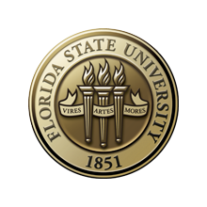

**Follow us!**

Twitter: @FSULifeCoaching

Facebook: FSU Advising First Center for College Life Coaching

***On your mark. Get set.***

***CONNECT! To FSU’s WiFi***

Quick Steps to CONNECT!:

1. Turn on your WiFi and select “FSUGuest.”
2. Open your browser and click “Guest Registration.”
3. Enter your cell phone number and carrier.
4. Click “Register.”
5. Check your cell phone for a text with a username and password.
6. Enter the username and password.
7. Click “Log In.”

#FSUCLCInstitute

**Keynote Speaker**

Dr. Billy Close

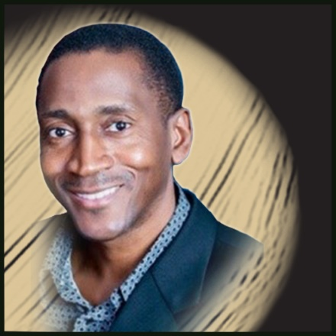

Dr. Billy Close is currently an Assistant Professor and Director of Service Learning and Mentoring in the College of Criminology & Criminal Justice at the Florida State University (FSU). Dr. Close is also President, Paradigm Consultants & Associates, Inc. and Founder & Executive Director of Beyond the Athlete, Inc., a 501(c) (3) non-profit organization committed to harnessing the powers of faith, family, sport, service learning, and mentoring for educational, character, and life skill development among youth & young adults. Dr. Close graduated from Lincoln High School in Tallahassee, Florida where earned High School All-American honors and was a two-time State Champion in Track and Field. Dr. Close earned a dual B.S. in Psychology and Criminology, and both his M.S. and Ph.D. degrees in Criminology and Criminal justice from FSU.

Dr. Close has served as a Member of Florida’s Council on the Social Status of Black Men and Boys, and as Board Member for several organizations including: The Leon County School Foundation, The Florida State University Athletics, The Florida State University International Programs Association, Inc., The Florida Department of Education College Reach-Out Program Advisory Council, The Tallahassee Associated Marine Institute, The Lincoln High School Alumni Association, and The FSU Varsity Club. His current research interests include Racial and Ethnic Differences in Traffic Stops and Driver Treatment, as well as the general areas of Theory & Dynamics of Minority Criminality, Racial Profiling, Sports & Crime, Mentoring Strategies for African-American Youth, Ethnicity and Methodology, Black Crimmythology, Conflict Reduction, and Multiculturalism. Dr. Close is married to Fran T. Close, Ph.D. who is currently a Professor in the Institute of Public Health and the College of Pharmacy and Pharmaceutical Sciences at Florida A& M University. They have three daughters, Nia Sekayi, Nataki Adia and Nyla Imani.

**Detailed Schedule**

|  |
| --- |
| WEDNESDAY, JUNE 6, 2018 |

|  |  |  |
| --- | --- | --- |
| 8:00 am-8:30 am | **Shuttle Services** | Four Points/ Visitor Parking to the Student Services Building (SSB) |
| 8:30 am-9:30 am | **Check-in & Breakfast** | *Location: SSB Foyer & 203* |
| 9:30 am-10:15 am | **Welcome & Keynote Address** | Shae Roberts, Program Manager  Dr. Billy Close, Keynote Speaker  *Location: SSB 203* |
| 10:30 am-12:15 pm | **Retention Issues & Program Specifics**  **(History, Structure, Staffing & Training)** | Shae Roberts, Manager  Ivan Myers, Asst. Manager  *Location: SSB 208* |
| 12:30 pm-1:30 pm | **Lunch** | *Seminole Café* |
| 1:45 pm-2:15 pm | **Building Tour or Team Builder Activity** | **Building Tour**  Erica Cucinella, FTIC Senior Coach  *Location: William Johnston Building*  **Team Builder**  Rolando Torres, FTIC Senior Coach  Felicia Dilbert, FTIC Coach  *Location: SSB 203* |
| 2:30 pm-4:30 pm | **Program Outcomes & Proposal Drafting** | Shae Roberts, Manager  Ivan Myers, Asst. Manager  *Location: SSB 208* |
| 4:30 pm-5:00 pm | **Shuttle Services** | SSB to Four Points/ Visitor Parking |
| 5:30 pm-until | **Networking (suggested)** | *Location: Madison Social*  *705 S. Woodward Ave #101*  *Tallahassee, FL 32304* |

|  |
| --- |
| THURSDAY, JUNE 7, 2018 |

|  |  |  |
| --- | --- | --- |
| 8:30 am-9:00 am | **Shuttle Services** | Four Points/ Visitor Parking to the Student Services Building (SSB) |
| 9:00 am-11:00 am | **Coaching Skills:**  **Create Safe Space, Connect, Affirm, Active Listening & Empowering Questions** | Ivan Myers, Asst. Manager  Erica Cucinella, FTIC Senior Coach  *Location: SSB 208* |
| 11:15 am-12:15 pm | **Concurrent Sessions:**  ***“Connections through peer coaching: A model for supporting student success”***  ***-OR-***  ***“Connecting the Team Before Impacting the Students’ Dreams: Using Personality Assessments to Create Team Cohesion”*** | **Peer Coaching**  Dr. Reginald Simmons  Alexandra Castillo  Central Connecticut State University  *Location: SSB 203*  **Team Cohesion**  Shae Roberts  Florida State University  *Location: SSB 208* |
| 12:30 pm-1:30 pm | **Lunch** | *Seminole Cafe* |
| 1:45 pm-3:30 pm | **Coaching Skills:**  **Holding Student Agenda, Prioritize, Clarifying Direction, Solution Focus & Confidence** | Shae Roberts, Manager  Erica Cucinella, FTIC Senior Coach  *Location: SSB 208* |
| 3:45 pm-4:45 pm | **Concurrent Sessions:**    ***“Coaching as Advising for High Achieving Students”***  ***-OR-***  ***“Implementing a College Life Coaching Program within the Academic Advising Center: Small School Perspective”*** | **High Achieving Students**  Megan Gillman  Florida State University  *Location: SSB 203*  **Small School Perspective**  Susan Gleason  Jodi Burns  University of Pittsburgh-Bradford  *Location: SSB 208* |
| 4:45 pm-5:15 pm | **Shuttle Services** | SSB to Four Points/ Visitor Parking |

|  |
| --- |
| FRIDAY, JUNE 8, 2018 |

|  |  |  |
| --- | --- | --- |
| 8:30 am-9:00 am | **Shuttle Services** | Four Points/ Visitor Parking to the Student Services Building (SSB) |
| 9:00 am-10:00 am | **Coaching Model** | Rolando Torres, FTIC Senior Coach  Erica Cucinella, FTIC Senior Coach  *Location: SSB 203* |
| 10:15 am-11:30 am | **Panel Discussion** | Various Panelists  *Location: SSB 208* |
| 11:30 am-12:00 pm | **Closing Session:**  **Passing the Baton** | Shae Roberts, Program Manager  *Location: SSB 203* |
| 12:00 pm-12:30 pm | **Shuttle Services** | SSB to Four Points/ Visitor Parking |

**Workshop Abstracts**

Thursday, June 7, 2018 11:15 am-12:15 pm

**Connections through peer coaching: A model for supporting student success** – SSB 203

*Dr. Reginald Simmons and Alexandra Castillo, Central Connecticut State University*

There is increasing recognition that pairing successful undergraduates similar in background and experience with other undergraduates in a mentoring relationship can be effective, particularly for enhancing the academic success of under-represented and first-generation students (Coleman Tucker, 2014; Johnson, 2013; & Strayhorn, 2012). One of the problems that some first-generation students experience is a lack of connection to their college campus, which is one of the non-academic factors that is key to college success (Lotkowski, Robbins, & Noeth, 2004). This presentation will introduce the audience to Success Central, a university-supported intervention where junior and senior students are trained to use college coaching techniques in a mentoring relationship designed to support the success of freshmen and sophomore first-generation students.  The audience will hear from the mentoring team how they were chosen, trained, and supervised, as well as case-studies that demonstrate the intervention and the benefits to both the mentee and the mentor.

***Connecting the Team Before Impacting the Students’ Dreams: Using Personality Assessments to Create Team Cohesion*** *– SSB 208*

*Shae Roberts, Florida State University*

Every team has the loud extravert, the quiet introvert, the sharp overachiever and the disengaged worker. Juggling all of these dynamics can be challenging and frustrating, and to add even more difficulty, every time someone leaves and/or is added, you have a brand new team! The key to strengthening cohesion is to build trust and transparency between the team and leadership, and between colleagues**.** Assessments such as True Colors ©, Myers Briggs ©, and Strengths Quest © are all tools available to identify the personality types, and strengths and weaknesses of the members on your team. However, assessment is only part of the equation. This interactive discussion will focus on the True Colors © assessment, setting structure, hiring based on your program’s vision and needs, addressing conflict based on personality types, and the importance of team building activities.

Thursday, June 7, 2018 3:45 pm-4:45 pm

***Coaching as Advising for High Achieving Students*** *– SSB 203*

*Megan Gillman, Florida State University*

Coaching has proven a highly effective technique for increasing retention and success of at-risk college students, but how might it help students at the other end of the achievement spectrum? Often advisors and professors assume that gifted and high-achieving students have everything figured out, but the use of coaching strategies can encourage tremendous growth in these students as well. This presentation offers insight into how coaching can be integrated into every day advising sessions with high-achieving college students in order to help them develop a strong sense of autonomy and encourage them to achieve goals they may not have imagined.

**Implementing a College Life Coaching Program within the Academic Advising Center: Small School Perspective** – SSB 208

*Susan Gleason and Jodi Burns, University of Pittsburgh-Bradford*

The College Life Coaching (CLC) program was implemented as a pilot program at the University of Pittsburgh at Bradford (UPB) for the duration of the 2017-18 academic year. The University of Pittsburgh at Bradford serves approximately 1,500 students. Students determined to be at-risk (provisionally admitted) were invited to participate in the inaugural CLC program. This population was chosen in an attempt to raise retention rates and lower the rate in which these students were placed on academic probation. This presentation will provide an overview of how a CLC program was implemented at a small institution with limited resources and an overlapping of staff responsibilities. We will also look through a critical lens at the outcomes of this crucial first year and will conclude by sharing our vision for the future.

**College Life Coaching Institute**

Gold Track Panelist Profiles

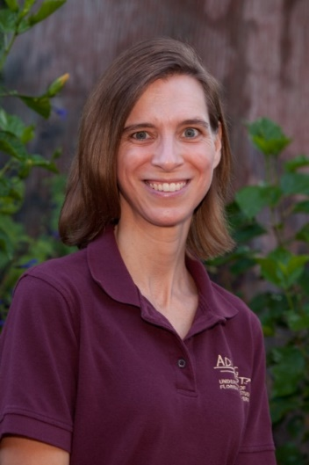**Nicole “Nikki” Raimondi** is a native of North Carolina who received her Bachelor’s degree in Psychology from Appalachian State University.  She then went on to receive her Master’s (University of Kentucky) and Doctorate degrees (Florida State University) in Marriage and Family Therapy.  She began her career in Higher Education at Florida State as an academic advisor in the College of Social Work in 2001. A few years later, she became the Associate Director, and then the Director, of Advising First. Nikki helped to launch the coaching program on campus in Spring of 2008, and currently, she serves as an Associate Dean within the Division of Undergraduate Studies. In her role, she acts as the academic dean for lower division students, handles the day-to-day functions of the dean’s office and manages the staff and responsibilities of the Office of Undergraduate Studies. She also provides oversight for the advising and coaching services provided by the Division of Undergraduate Studies and serves on many campus-wide committees concerned with academic policy, student success and student retention.

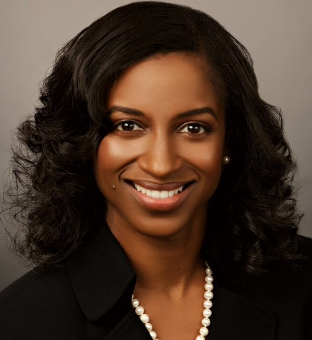**Rose-May Frazier** serves as the director of Advising First in the Division of Undergraduate Studies.  Throughout the past 13 years Rose-May has developed a deep understanding and appreciation for the organizational process of helping students achieve their goals.  A significant part of this expertise was developed while working as an advisor for two years, and as a College Life Coach for an additional two years. The Director of Advising First is responsible for the effective day-to-day functioning, oversight, and interfacing of Advising First academic advising and coaching units in the Division, as well as selection and supervision of academic advisors and coaches. Rose-May collaborates across various departments and campus-wide committees developing policies to better meet the advising/coaching needs of students. She is also a liaison to academic deans' offices and departments to coordinate academic advising and coaching, assisting in developing policies and procedures for the purpose of maximizing successful student outcomes. Rose-May and her teams have shared their works at NACADA, NASPA and other professional organizations.  Her work also includes receipt of the NACADA Commission-Sponsored Conference Presentation by the Multicultural Concerns Commission. Rose-May is from Miami Gardens, Florida by way of New York City, earning her bachelor and master's degrees from Florida State University, while currently a PhD candidate at Florida A&M University. Rose-May believes that College Life Coaching impacts her current role daily with students and colleagues. Not only have these skills been beneficial with students, but she finds herself utilizing these skills outside of the university as well. Rose-May remains thankful for the continued training that has supported her in becoming a more effective leader.

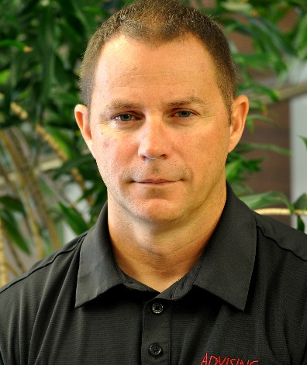**John Carter** is a Tallahassee native by birth. John received his Bachelor’s degree from Florida State University and has since stayed to work at Florida State for twenty-three years. His very first job was in the Registrar’s Office at FSU. John has been the Associate Director of Advising First for over 10 years and has had the privilege of seeing it transform over time. In his role, John is responsible for not only the logistical operations of the Advising First department but also plays a key role in leadership decisions with regards to the direction of Advising First. John believes that coaching has created an effective way to reach and engage students, connecting them with campus resources and opportunities that can positively influence their time at Florida State.

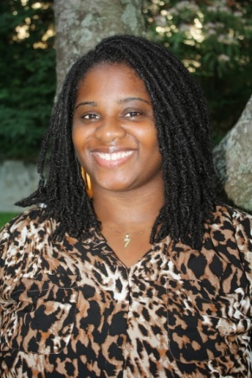**LaShae “Shae” Roberts** was born and raised in Fort Lauderdale, Florida, and attended Florida State University. She earned her Bachelor’s degree in Criminology and Sociology, and a Master’s degree in Criminology. She is currently enrolled in courses seeking a Master’s in Clinical Social Work. Shae is the Assistant Director of Advising First and manages the College Life Coaching Program. She has presented about the program at FLACADA, NACADA and NCLCA regional and national conferences. She has worked with Advising First for eight years as a Coach, Senior Coach, Assistant Program Manager and Program Manager of the Coaching Center. As the Program Manager, she handles a lot of the day-to-day tasks of the center while supervising a staff of 16 coaches. Shae enjoys building relationships with campus partners, managing data, creating reports, analyzing performance, mentoring the coaching leadership team, and serving the Advising First department. Other duties include strategic planning, staffing decisions, and policy development and implementation. As a first-generation college student, she wishes she had a coach. Shae believes that coaching does not tell the student what to do, instead, coaches collaborate with and encourage students to be proactive and involved in their own success. This concept has transformed her approach as a professional and leader.

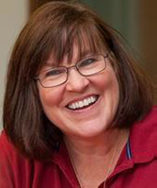**Linda Burns** received her BS in Nursing from Florida State University in 1977, but has spent most of her professional life in the field of education. She was part of the Advising First Success Coaching pilot program in 2008 and enjoyed two years as a full-time success coach, the 2nd year as the first senior coach in the program. Linda transitioned to the Center for Exploratory Students, serving as the Program Manager and later as Assistant Director of Advising First. She has recently returned to the College of Nursing where her educational journey started and is working with freshmen and sophomores applying to the program. She is active in NACADA and has presented at the state, regional, and national level on coaching and advising issues. Linda states, “I use my background in coaching every day as I advise students. How do you advise a student toward a goal? Coaching! How do you help a student develop insight into their situation? Coaching! How do you truly make a difference in a student’s life? Coaching!”

**Thank you to our Sponsors!**

**Off Campus:**

Barefoot Campus Outfitter

Smoothie King

**On Campus:**

Askew Student Life Center

FSU Bookstore

Career Center

Center for Global Engagement

Center for Health Advocacy and Wellness

Center for Leadership and Social Change

Dean of Students

Honors Program

FSU International Programs

Medical Response Unit

Museum of Fine Arts

Office of Business Services

Student Veterans Center

University Health Services Administration (5th Floor)

University Center Club

FSU Visitor Center

Askew Student Life Center is offering free admission to see Tomb Raider at 9:30 pm on Wednesday, June 7th, and Thursday, June 8th. See Institute bag for $1 popcorn ticket.

Address: 942 Learning Way, Tallahassee, FL 32304